**CDAC Mumbai PG-DAC AUGUST 24**

**Assignment No- 2**

**1)Write a program that checks if a given year is a leap year or not using both if-else and switch-case.**

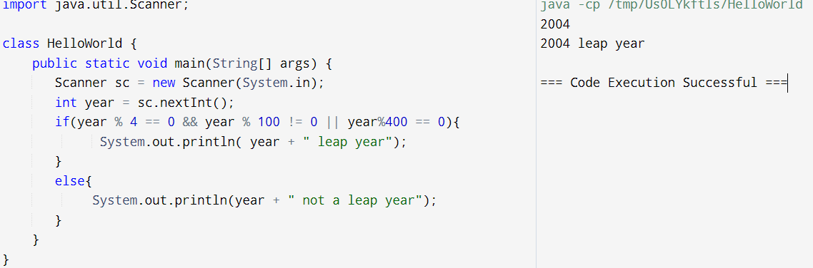

import java.util.Scanner;

class HelloWorld {

public static void main(String[] args) {

Scanner sc = new Scanner(System.in);

int year = sc.nextInt();

if(year % 4 == 0 && year % 100 != 0 || year%400 == 0){

System.out.println( year + " leap year");

}

else{

System.out.println(year + " not a leap year");

}

}

}

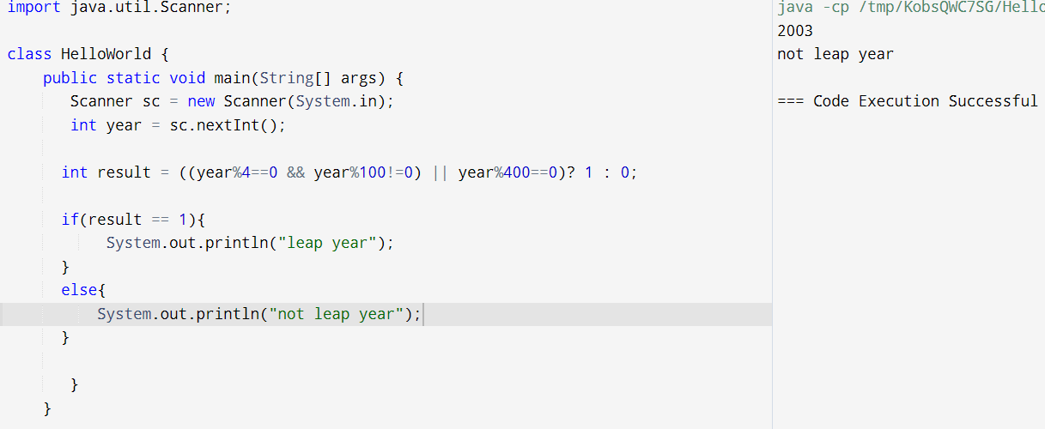

import java.util.Scanner;

class HelloWorld {

public static void main(String[] args) {

Scanner sc = new Scanner(System.in);

int year = sc.nextInt();

int result = ((year%4==0 && year%100!=0) || year%400==0)? 1 : 0;

if(result == 1){

System.out.println("leap year");

}

else{

System.out.println("not leap year");

}

}

}

**2)Implement a program that calculates the Body Mass Index (BMI) based on height and weight input using if-else to classify the BMI int categories (underweight, normal weight, overweight,etc).**

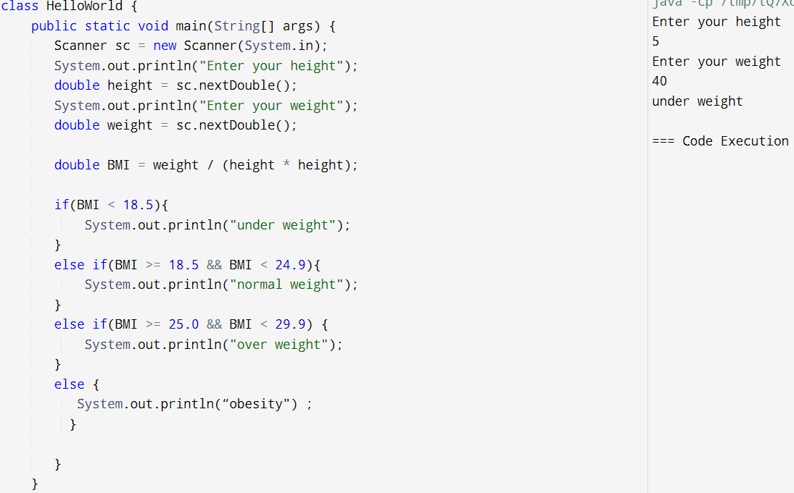

import java.util.Scanner;

class HelloWorld {

public static void main(String[] args) {

Scanner sc = new Scanner(System.in);

System.out.println("Enter your height");

double height = sc.nextDouble();

System.out.println("Enter your weight");

double weight = sc.nextDouble();

double BMI = weight / (height * height);

if(BMI < 18.5){

System.out.println("under weight");

}

else if(BMI >= 18.5 && BMI < 24.9){

System.out.println("normal weight");

}

else if(BMI >= 25.0 && BMI < 29.9) {

System.out.println("over weight");

}

else {

System.out.println(“obesity") ;

}

}

}

**3)Write a program that checks if a person is eligible to vote based on their age.**

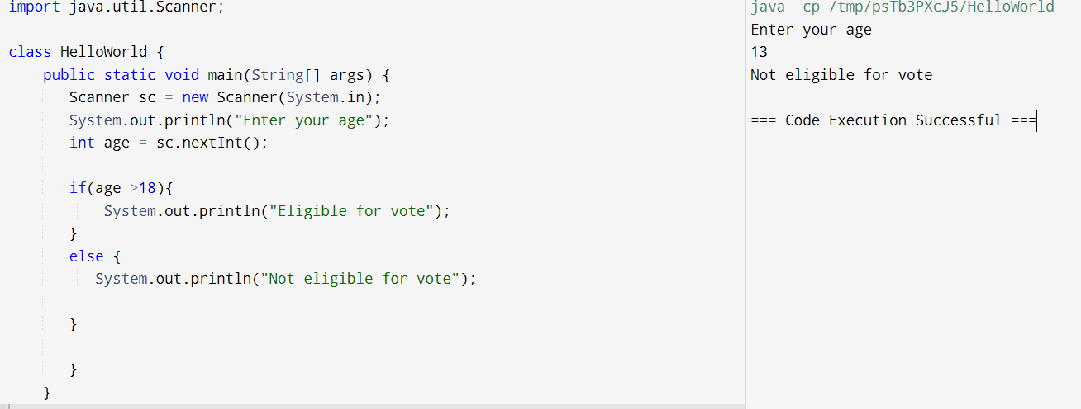

import java.util.Scanner;

class HelloWorld {

public static void main(String[] args) {

Scanner sc = new Scanner(System.in);

System.out.println("Enter your age");

int age = sc.nextInt();

if(age >18){

System.out.println("Eligible for vote");

}

else {

System.out.println("Not eligible for vote");

}

}

}

**4)Write a program that takes a month (1-12) and prints the corresponding season (Winter, Spring, Summer, Autumn) using a switch case**

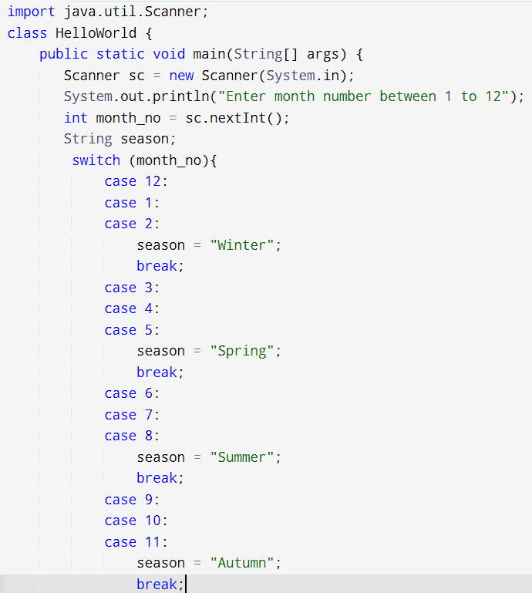

import java.util.Scanner;

class HelloWorld {

public static void main(String[] args) {

Scanner sc = new Scanner(System.in);

System.out.println("Enter month number between 1 to 12");

int month_no = sc.nextInt();

String season;

switch (month_no){

case 12:

case 1:

case 2:

season = "Winter";

break;

case 3:

case 4:

case 5:

season = "Spring";

break;

case 6:

case 7:

case 8:

season = "Summer";

break;

case 9:

case 10:

case 11:

season = "Autumn";

break;

default:

season = "Invalid month. Please enter a number between 1 and 12.";

break;

}

System.out.println(season);

}

}

**5)Write a program that allows the user to select a shape (Circle, Square, Rectangle, Triangle) and then calculates the area based on user-provided dimensions using a switch case.**

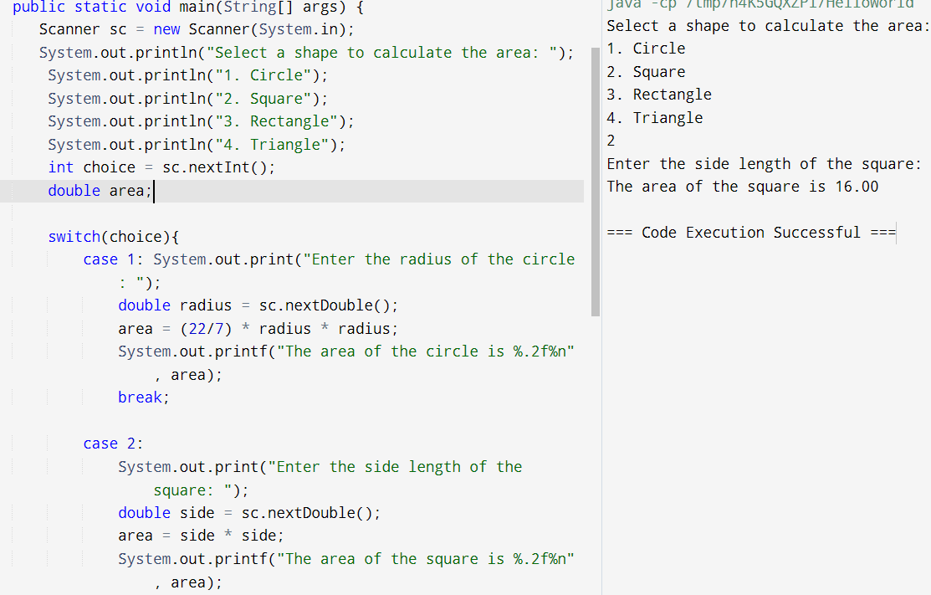

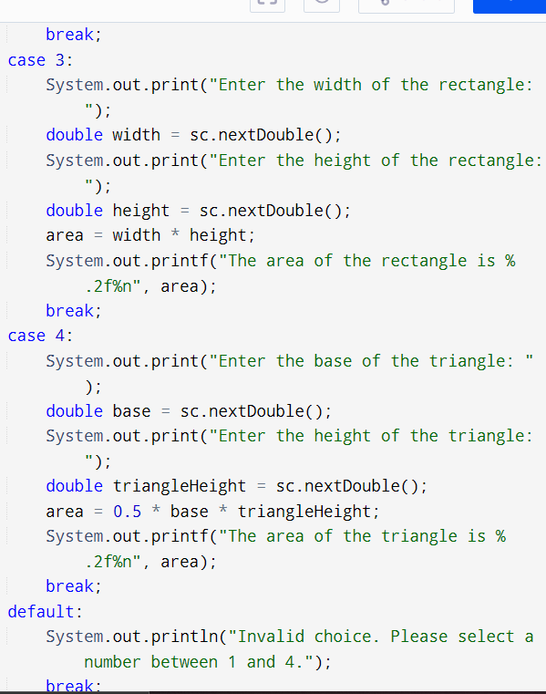

**import java.util.Scanner;**

class HelloWorld {

public static void main(String[] args) {

Scanner sc = new Scanner(System.in);

System.out.println("Select a shape to calculate the area: ");

System.out.println("1. Circle");

System.out.println("2. Square");

System.out.println("3. Rectangle");

System.out.println("4. Triangle");

int choice = sc.nextInt();

double area;

switch(choice){

case 1: System.out.print("Enter the radius of the circle: ");

double radius = sc.nextDouble();

area = (22/7) * radius * radius;

System.out.printf("The area of the circle is %.2f%n", area);

break;

case 2:

System.out.print("Enter the side length of the square: ");

double side = sc.nextDouble();

area = side * side;

System.out.printf("The area of the square is %.2f%n", area);

break;

case 3:

System.out.print("Enter the width of the rectangle: ");

double width = sc.nextDouble();

System.out.print("Enter the height of the rectangle: ");

double height = sc.nextDouble();

area = width * height;

System.out.printf("The area of the rectangle is %.2f%n", area);

break;

case 4:

System.out.print("Enter the base of the triangle: ");

double base = sc.nextDouble();

System.out.print("Enter the height of the triangle: ");

double triangleHeight = sc.nextDouble();

area = 0.5 * base * triangleHeight;

System.out.printf("The area of the triangle is %.2f%n", area);

break;

default:

System.out.println("Invalid choice. Please select a number between 1 and 4.");

break;

}

}

}